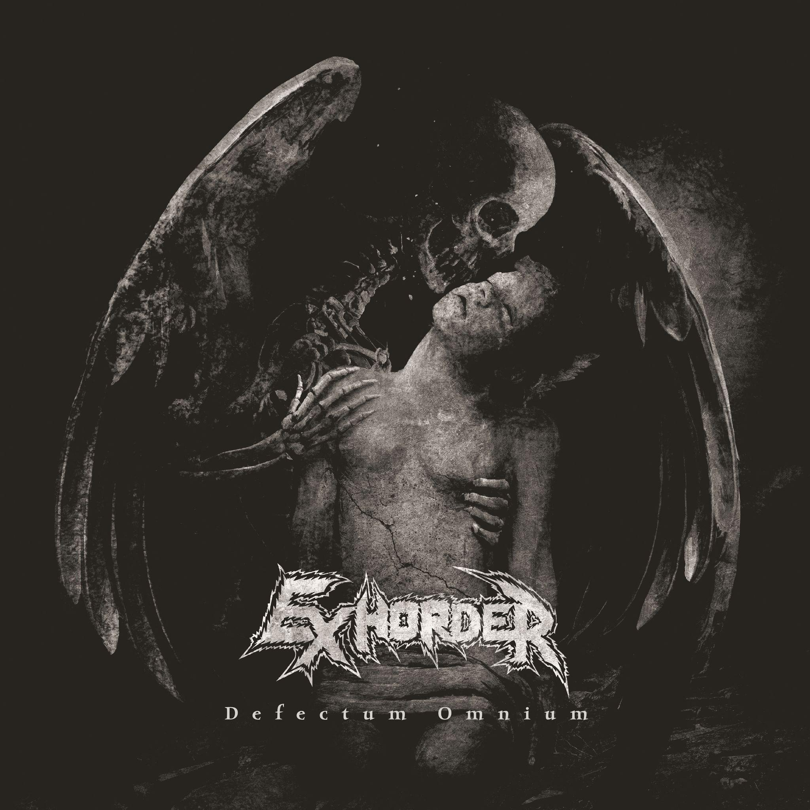
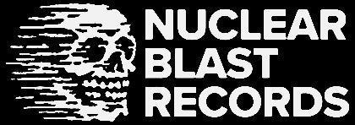

EXHORDER
Defectum Omnium

Release Date: March 8th, 2024

Line up: | EXHORDER online:
Kyle Thomas | vocals, guitar  Pat O’Brien | lead guitar  Sasha Horn | drums  Jason VieBrooks | bass, guitar | www.exhorder.com  www.facebook.com/exhorderofficial  www.instagram.com/exhorderofficial/  www.twitter.com/exhordernola  www.instagram.com/exhorderofficial
Formed in 1986, EXHORDER’s journey has proven exciting, yet tumultuous. After a twenty-seven-year absence following their final Roadrunner Records release in 1992, EXHORDER re-entered the game with an album considered by many to be a contender for the "Best Comeback Album" category. The band released Mourn the Southern Skies in October of 2019 through Nuclear Blast Records. Fraught with euphoric peaks and crippling valleys throughout its existence, lineup changes, and the 2020-2021 pandemic, EXHORDER has since clawed back through the muck to prepare yet another album to add to the discography. In the spring of 2024, EXHORDER presents yet again via Nuclear Blast their fourth full-length recording, Defectum Omnium, the Latin phrase for "The Failure of All". Singer Kyle Thomas wryly explains that the album title is representative of the current state of affairs that the world is in. "The world is a dumpster fire, and we are all complicit.", he explains. "People have been talking about, ‘...viruses killing us off, blah-blah, blah...', when in actuality WE are the virus to the Earth. Mother Nature is simply trying to shake off the fleas, and her ‘viruses’ are the antibodies combating US. Earth will survive, and we will join the dinosaurs, wooly mammoths, and saber-toothed tigers soon enough in her history."

Produced by EXHORDER and mixed by Jens Bogren, Defectum Omnium puts a foot back into the roots of the band's inception. The scales have tipped favorably towards the presence of punk and thrash more so than on Mourn the Southern Skies. Tracks like ‘Wrath of Prophecies’, ‘Forever and Beyond Despair’, and ‘Sedition’ are what EXHORDER comes by most honestly when referring to their beginnings. There is also a strong presence of doom influence, as always. ‘The Tale of Unsound Minds’ and the haunting ‘Defectum Omnium/Stolen Hope’ will raise utter despair from the depths of your soul. The thick New Orleans grooves EXHORDER has been known for beating out since day one are still undeniable, and they stand out in tracks like ‘Year of the Goat’, ‘Under the Gaslight’, and ‘Three Stages of Truth/Lacing the Well’.
One trait about Defectum Omnium that deserves to be pointed out is that it is more of a journey and experience than just a regurgitated selection of songs on autopilot. With peaks and valleys much like a roller coaster ride, one listener described the album as having "...a little something for everyone.". As EXHORDER has always been hard to classify by one genre, the album is loaded with heaviness, aggression, speed, and venom. It also has an equal presence of mystery, melody, and harmony, and vacillates between darkness and light. Themes that dart back and forth between surviving oppression, despair, revolution, and brittle hope take you through the band's madness by way of the musical path that they have forged. With touring plans underway in support of Defectum Omnium, EXHORDER finds itself poised to finally achieve the brass ring potential that has always seemed to be just out of their reach.

